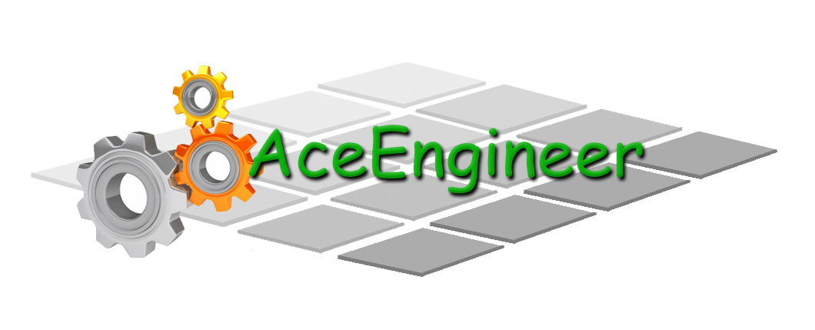
Engineering for everyday world

AceEngineer

Python Manual

Development Document

19th December 2015

19-Dec-2014 | 01 | New Issue |  |  |  |  | VA | - | -
DATE | REV | DESCRIPTION |  |  |  |  | ORIG | CHK | APPR
DOCUMENT CONTROL NO |  | Project | Type | Area | Client | - | - | Sequence | Revision
 |  | 0026 | PY | - | - | - | - | 0001 | 01

Revision History:

REV | DATE | DESCRIPTION | ORIG | CHK | APPR
01 | 9th Dec 2014 | Manual for ANSYS for editing, modelling and simulation | MP | VA | VA

Change Log

REV | SECTION | CHANGE DESCRIPTION
Document Holds
Hold | DESCRIPTION

CONTENTS
1 Introduction 4
2 Programing 4
3 How to PY 4
3.1 Functions 4
3.1.1 Built-in Functions 4
3.2 Modules 4
3.2.1 Importing modules 4
3.2.2 Directory 4
3.2.3 Accessing module functions. 5
3.3 Working with Files 5
3.4 Passing Arguments 5
3.5 Desktop Application Programming 5
3.6 Desktop Application Programming 5
4 Installation and Set up 5
4.1 Module 5
4.2 Calling .PY files 6
5 Working with Excel 6
5.1 Resources 6
6 Dynamic WebPages 6
6.1 Web Platform 6
7 Saving Data 6
8 Plots 7
8.1 D3JS 7
9 References 7

Introduction
Python programming language is a very simple object oriented language. It can be used by any person with any existing program available. It helps in easy customization and optimization of softwares, websites etc.

Highlight Features
Compiler/Interpreter is not required.
The program interprets the commands directly
Program is case sensitive

Programing

How to PY

Resources
https://www.youtube.com/watch?v=cIH6TjK0H5s&list=PLqaJe1KXgdP0UyO_JptIwn8GccfL9QANl

Functions

Built-in Functions
Can be accessed by
Dir (__builtins__)

Modules
Help (“Modules”) will show all available modules. Some modules of interest are:
Math
Pydocs
Etc.
Etc.

Importing modules
import math
import os
import PyPDF2

Directory
Specifying:
Note the double backslash (\\) below for directories:
'C:\\Users\\vamsee.achanta\\Dropbox (STA SEWOL)\\Engineering\\0119 Programming\\Py\\PDFReader'

Change: Os.chdir

Find current directory: os.getcwd

Accessing module functions.
Math.acos
Math.sqrt

Working with Files
- To read a file in the default folder, no modules are required.
- If working with other files or create new directories in the computer, OS module is required to be imported

Passing Arguments
Passing arguments and printing a text interspersed with values is very intuitive. All variable arrays can be stacked towards the end of the line. See below example.e

The name is %s and the age is %f (var_name,var_age)

Desktop Application Programming
Desktop applications can also be developed using Python.
GUI programming with
- Buttons
- Textboxes
- Other calculations
- Menubar using “Menu” class
- Etc.

Desktop Application Programming

Installation and Set up

Module – Method 1
- In command prompt, go the directory where the module set up files are located
CD “C:\Users\vamsee.achanta\Downloads\PyPDF2-1.25.1\”
- Run Python on the setup file as follows:
C:\Python\Python35-32\python.exe setup.py install
- Restart Python (if necessary).
- The files should be installed and ready to use.

References:
http://dubroy.com/blog/so-you-want-to-install-a-python-package/
https://docs.python.org/3.6/installing/index.html

Module – Method 2

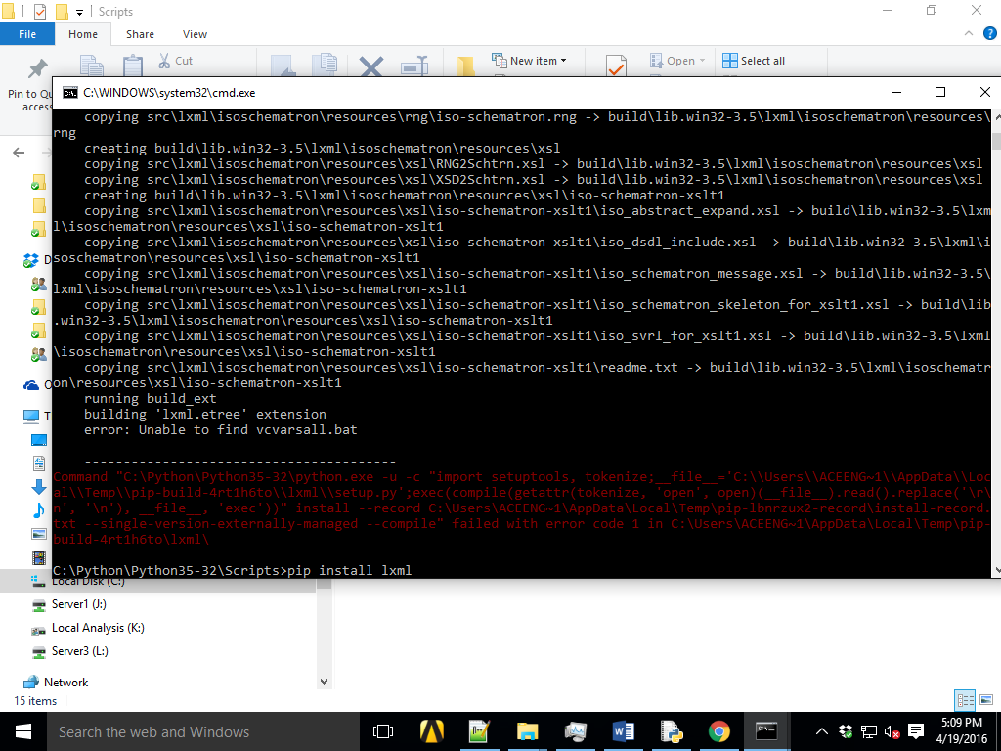

Calling .PY files
In Shell IDLE
subprocess.call(['python','HelloWorld.py'])
subprocess.check_output (['python','HelloWorld.py'])

In Command Prompt
import subprocess
subprocess.call(['python','HelloWorld.py'])

Working with Excel

Resources
http://www.python-excel.org/
http://www.simplistix.co.uk/presentations/python-excel.pdf
https://automatetheboringstuff.com/chapter12/
http://stackoverflow.com/questions/2141967/using-python-to-program-ms-office-macros
http://timgolden.me.uk/pywin32-docs/html/com/win32com/HTML/QuickStartServerCom.html
http://ironpython.net/ .NET framework IDE

Working with Word

Description | Value
Module | python-docx
import | docx
Table 1 – Working With Word Overview

Setup
Installation
- Download latest version from below link:
https://pypi.python.org/pypi/python-docx
- Install module as per instructions provided in Section 4.1

Writing a small Program

References
http://python-docx.readthedocs.org/en/latest/user/documents.html
https://automatetheboringstuff.com/chapter13/

Dependencies
https://pypi.python.org/pypi/lxml/3.6.0#downloads

Working with PDF

Dynamic WebPages
????

Web Platform
Set up a live platform or Django?
https://www.djangoproject.com/

Prepare set up for a general project

Prepare set up for a drilling riser analysis project

Saving Data

CSV without header and footer
JSON format (with header and footer)
Understand the plotting tools before choosing data format and minimize parsing this after writing the data.

References
http://www.inquidia.com/news-and-info/hadoop-file-formats-its-not-just-csv-anymore

Plots

References:
https://plot.ly/python/
https://d3js.org/

D3JS
An introduction to D3JS
https://www.youtube.com/watch?v=8jvoTV54nXw

https://github.com/curran/screencasts/tree/gh-pages/introToD3

Setup the first chart

References
Books

https://automatetheboringstuff.com/#toc Automate the boring stuff

http://www.javatpoint.com/python-tutorial
http://www.tutorialspoint.com//python/index.htm

- Practice Examples

Read and Write Text Files
Read a text file with 2 numbers
Perform mathematical operation
Output the files

-

Unable to find vcvarsall.bat

http://stackoverflow.com/questions/2817869/error-unable-to-find-vcvarsall-bat

http://stackoverflow.com/questions/27670365/python-pip-install-error-unable-to-find-vcvarsall-bat-tried-all-solutions

https://wiki.python.org/moin/WindowsCompilers#Microsoft_Visual_C.2B-.2B-_14.0_standalone:_Visual_C.2B-.2B-_Build_Tools_2015_.28x86.2C_x64.2C_ARM.29

